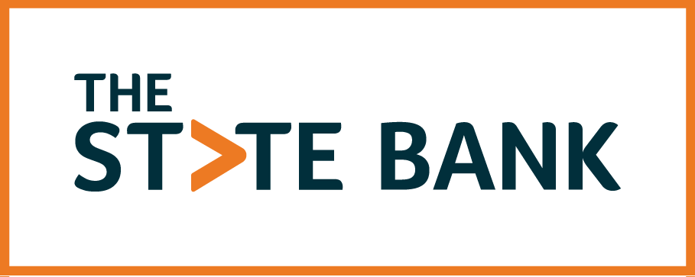

ELECTRONIC STATEMENTS, ELECTRONIC NOTICES AND ELECTRONIC SIGNATURES DISCLOSURE AND USER AGREEMENT

Before you may use The State Bank’s (the “Bank,” “we,” “our,” or “us”) online document delivery, retention, and signature process (defined herein), you must agree to this Electronic Statements, Electronic Notices and Electronic Signatures Disclosure and User Agreement (the “Agreement”). Before agreeing to the Agreement, you must consent to receive it and any future amendments and changes to the Agreement, along with signature cards, account terms and conditions, communications, documents, disclosures, agreements, notices, and any and all documents required by State or federal law and any other form required to be signed by the Bank, including any and all amendments and changes to these documents, (collectively “Documents”) in connection with any deposit account, loan you receive or have received by the Bank, any deposit account established at the Bank, and any online banking services you use, This Agreement is required by the Federal Electronic Signatures in Global and National Commerce Act (“ESign Act”) in order for us to provide you with the Agreement and Documents electronically. Please read this Agreement carefully and keep a copy for your records.

For purposes of this Agreement, the online document delivery, retention, and signature process shall mean the Bank’s online platform that allows consumers to apply for, receive, consent to, agree, and sign Documents electronically (“Online Platform”), Online Banking, and/or Mobile Banking. The Online Platform may be provided by a third party on behalf of the bank. Any third-party vendor used to provide the Online Platform is not affiliated with the Bank and the account is subject to separate terms and conditions of use. Separate fees may apply.

TECHNICAL REQUIREMENTS: To access and retain Documents, you will need the following: 1) Internet access and an Internet email account and address; 2) Microsoft Internet Explorer 11.0 or higher, the most recent version of Google Chrome or Mozilla Firefox, or Apple Safari 6.0, all with 128- bit encryption; 3) Adobe Acrobat Reader 11.0 or higher; 4) Access to a printer or the ability to download information in order to keep copies of the Documents for your records. We will notify you of any material change in hardware or software required for retrieving or storing your statement or disclosure by placing a message on online banking.

Adobe Requirements https://helpx.adobe.com/sign/system-requirements.html

To access and retain periodic statements, and other Documents pertaining to your deposit account with the Bank, you will need Online Banking through The State Bank. You will need to make elections within the Online Banking system to stop receiving paper Documents in certain instances as discussed below.

DELIVERY OF DOCUMENTS: If the Document is sent through the Online Platform, you will receive an email when a Document is available for your review, consent, and signature. The email will provide you with a link to the Bank’s Online Platform. The Bank will never ask you to provide nonpublic personal information through email.

Other Documents will be delivered through Online Banking or Mobile Banking. Certain Documents are not available through Mobile Banking. The Bank reserves the right to change the availability of Documents through Online Banking or Mobile Banking. Your consent will apply to Documents to the extent of availability in each delivery system, now and in the future.

ELECTRONIC STATEMENTS AUTHORIZATION THROUGH ONLINE BANKING: If you have Online Banking, you may elect to receive electronic periodic statements and notices only. If you make the election in the system, you are affirmatively consenting to receive your periodic account statements and/or other deposit and loan notices electronically. If your account is owned jointly with another person(s), any one of you may consent to electronic statements and/or notices and that person’s election to access electronic statements and/or disclosures shall apply to all of you. Further, you are agreeing to discontinue the receipt of a paper statement and/or notices for the checking, savings, money market, certificate, or loan accounts indicated by you. If you do not make the selection within Online Banking, you will continue to receive electronic periodic statements and notices in paper form. However, other forms of Documents will be sent in electronic form only, in accordance with this Agreement.

PAPER DELIVERY AND HOW TO DISCONTINUE ELECTRONIC DELIVERY OF DOCUMENTS: You have the right to receive a paper copy of the Agreement and Documents. To receive a free paper copy, please request it/them in one of the following ways: 1) sending us an email message through online banking (do not include your account number or non-public personal information in the email as email is not secure); 2) telephone at (800) 535-0517; or 3) writing by U.S. Mail at: The State Bank, P.O. Box 725, Fenton, MI 48430-0725. At any time you may revoke your consent to electronic delivery of Documents, other than your consent to receive this Agreement, unless you have a checking account that requires electronic statements and notices as a condition of the account. To revoke your consent, notify us by telephone at (800) 535-0517 or in writing by U.S. Mail at: The State Bank, P.O. Box 725, Fenton, MI 48430-0725. We reserve the right to impose or change fees for terminating this Agreement and switching back to paper statements.

PASSWORD SECURITY: Your User ID and password that are used to access online banking services should be kept confidential; to protect the security of your banking information you must not disclose or share your password with any third party. We strongly recommend that you change your password regularly. You are responsible for keeping your password, account numbers, and other account data confidential.

YOUR RESPONSIBILITY TO UPDATE YOUR ELECTRONIC CONTACT
INFORMATION: We will send notification of all electronic statements and notices via email to the last known email address provided by you. You agree to promptly notify the Bank if there is a change in your email address or any other information needed to contact you.

FEES FOR ELECTRONIC STATEMENTS/NOTICES: The Bank does not charge fees for electronic delivery of electronic statements/notices. We reserve the right to impose or change fees for electronic delivery and charge your deposit account for these fees at any time after providing such notice to you as may be required by law or regulation.

ELECTRONIC RETENTION OF RECORDS: You agree that the Bank, at its option, may retain the Agreement and Documents in electronic format only. This includes documents pertaining to your loan, including your note and mortgage. If retained electronically, the electronic copy shall be considered an original.

CHANGES TO THE AGREEMENT AND/OR DOCUMENTS: You understand and agree that the Bank retains the right, to the extent permitted by law, to amend this Agreement and any Document at any time without consent by providing you with written notice of such change electronically and in accordance with this Agreement or via mail to your last known mailing address.

ELECTRONIC SIGNATURE (eSignature): You consent and agree that your use of a key pad, mouse, or other device to select an item, button, icon or similar act/action while using any electronic service we offer; or in accessing or making any transactions regarding any agreement, acknowledgment consent, terms, disclosure or conditions constitutes your signature, acceptance and agreement as if actually signed by you in writing in accordance with the ESign Act and Michigan’s Uniform Electronic Transactions Act (“eSignature”). Further, you agree that no certification authority or other third party verification is necessary to validate your electronic signature and that the lack of such certification or third party verification will not in any way affect the enforceability of your signature or resulting contract between you and The State Bank. Also, you understand and agree that your eSignature executed in conjunction with the electronic submission of your application, including your intent to apply for joint credit shall be legally binding and shall be considered authorized by you. In addition, you agree that your Electronic Signature shall have the same effect as if you had signed the Document or electronic record in ink.

ACKNOWLEDGMENT: You agree to the terms and conditions of this agreement.

Confirmation code: 1058

